**SETTING UP AN APPLICATION ENVIRONMENT**

|  |  |
| --- | --- |
| **Date** | 19 October 2022 |
| **Team Id** | PNT2022TMID07988 |
| **Project Name** | Inventory Management System for Retailers |
| **Maximum Marks** | 4 Marks |

**CLOUD ACCOUNT**

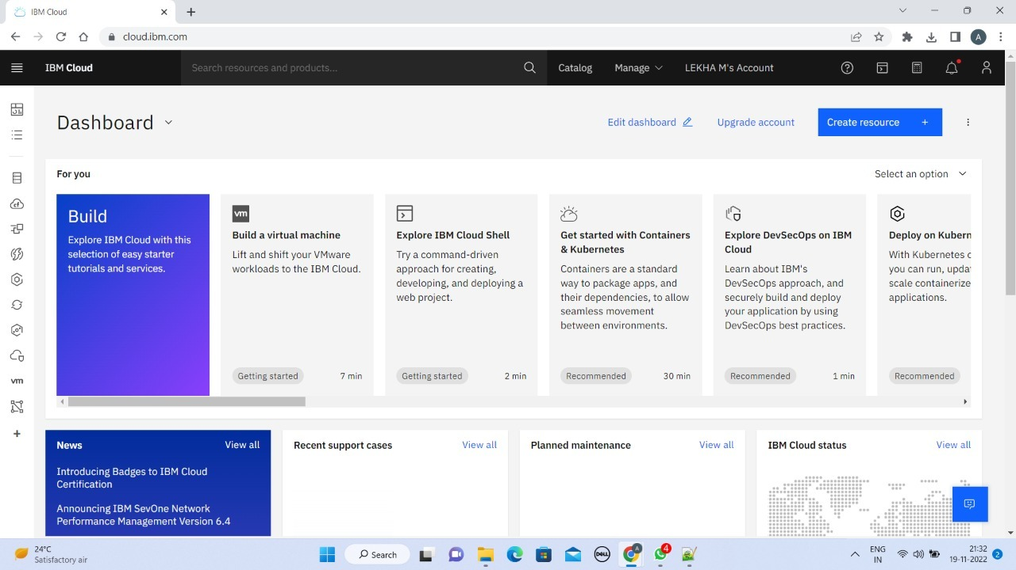

**CREATING AN FLASK PROJECT**

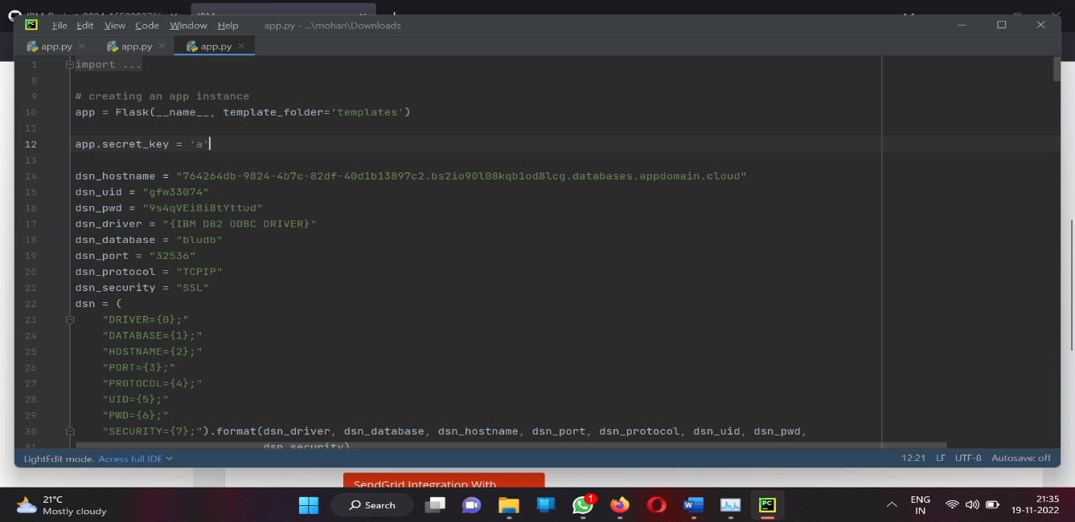

**DOCKER CLI INSTALLATION**

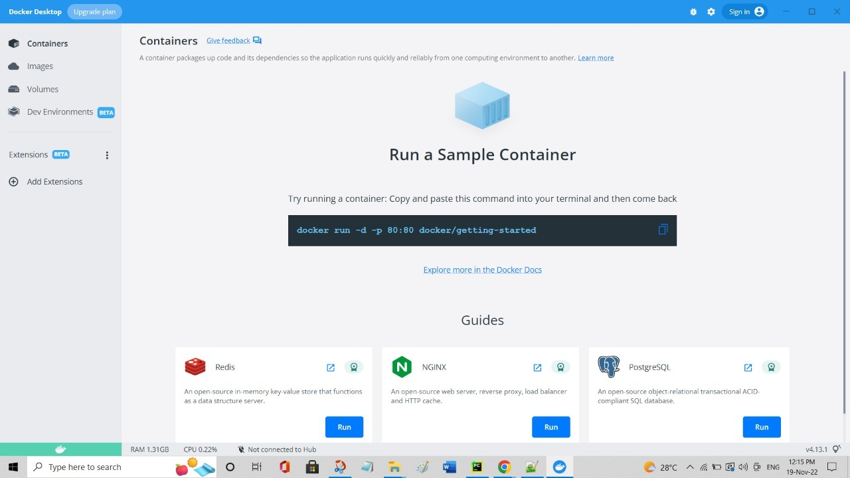

**CREATING AN SENDGRID**

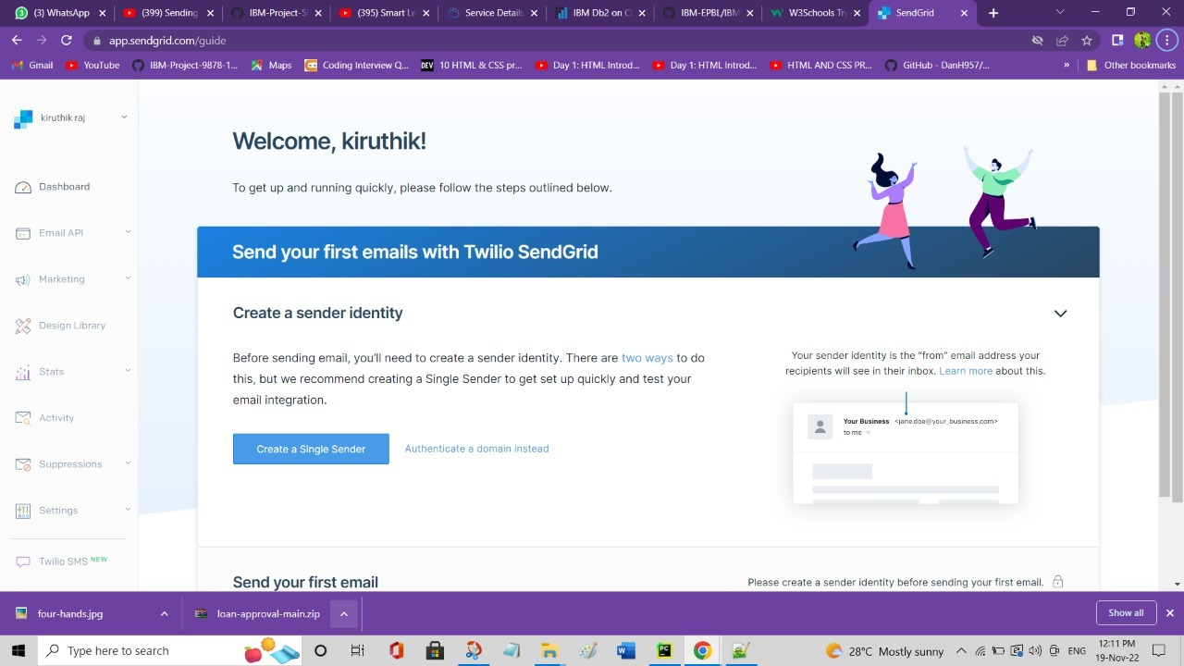

**INSTALLING IBM CLOUD CLI**

